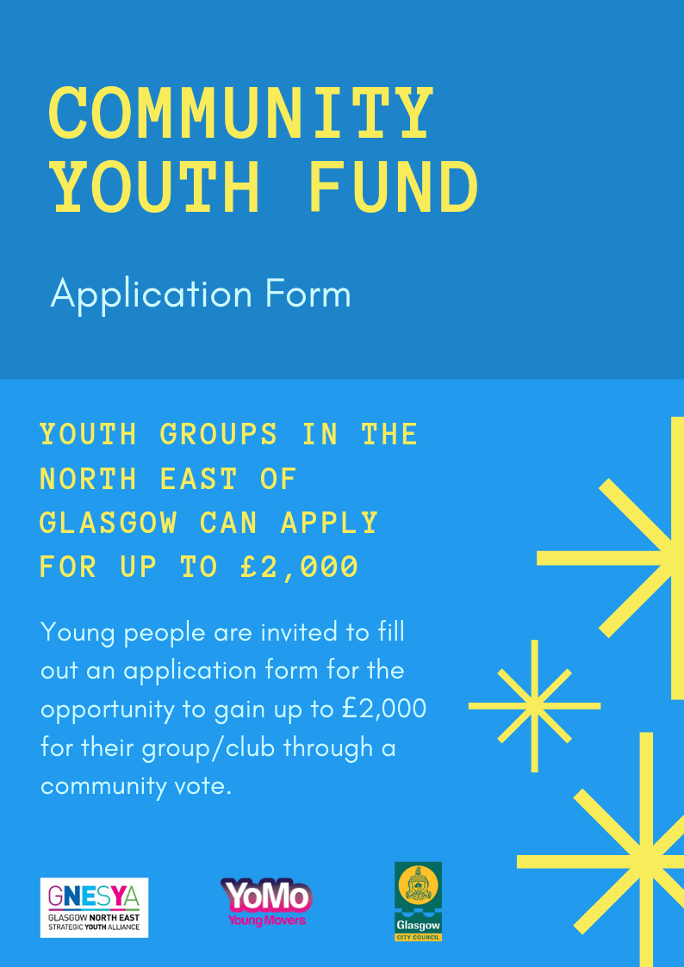

Criteria & Information

Who can apply?
- Young people between the age of 10-25 years old from the North East of Glasgow
- Project ideas must be led & based on the ideas of young people.

How much is available?
- You can apply for between £100 to £2,000
- The total amount of money we have to distribute is £20,000

What are the priorities for this funding?
- Projects that provide new opportunities for young people
- Equipment & materials for youth activity
- Projects that promote health and wellbeing

Before you apply:
- Please read the application form fully
- If you are unsure if your proposal is suitable for this programme just get in touch and we will advise you

How to apply:
- Return this completed application form to caitlin@yomo-online.co.uk
- Application deadline: 3pm Wednesday 13th March 2019.

What happens next?
- A steering group made up of young people will review the applications received and based on the criteria and priorities listed above will shortlist a number of projects that will put to a public vote at the decision making event
- You will be asked to attend the voting event on Friday 22nd March 2019 and make your case for funding, through an information stall.
- Members of the community and other applicants will then vote on who gets funded.

YOUR IDEA
Idea name: | Click or tap here to enter text.
Individual/ group/ organisation name: | Click or tap here to enter text.

CONTACT DETAILS
Please provide us with the contact detail of the person we should contact to let them know about the progress of your application.
Name: | Click or tap here to enter text.
Email: | Click or tap here to enter text.
Contact number: | Click or tap here to enter text.

WHAT IS THE IDEA YOU WANT FUNDING FOR?
Let us know what you plan to do. Think about:
- What activities will take place?
- How often will the activity take place and where?
- Describe the people who will get involved (e.g. are they younger or older? Do they have a disability? Are they mostly women?)
- This would be a good place to mention if you meet one of the priorities and how you do so?
Click or tap here to enter text.

WHAT DIFFERENCE WILL YOUR IDEA MAKE TO NORTH EAST GLASGOW?
Let us know what will change because of your idea. Think about:
- What will change for the individual involved? (e.g. they may have learned a new skill, made new friends or be happier)
- What will change for young people in the North East of Glasgow (e.g. your idea might increase services for locals, give volunteers the resources and tools they need to improve the area)
Click or tap here to enter text.
PROJECT COSTS
We need to know how much your project will cost, whilst you can apply for up to £2,000 it is important that you only apply for what you need to enable as many ideas to be supported as possible.
Item | Cost
Click or tap here to enter text. | Text.
Click or tap here to enter text. | Text.
Click or tap here to enter text. | Text.
Click or tap here to enter text. | Text.
Click or tap here to enter text. | Text.
Click or tap here to enter text. | Text.
Click or tap here to enter text. | Text.
Click or tap here to enter text. | Text.
TOTAL | Text.
SUPPORTING ADULT CONTACT DETAILS
Please provide the details of a supporting adult e.g youth worker who we can contact about the progess of your application.
Name: | Click or tap here to enter text.
Email: | Click or tap here to enter text.
Contact number: | Click or tap here to enter text.

